Neuro-Financial FusionNet: An Ensemble Transformer and Graph Neural Network for Macroeconomic Trend Prediction

1. Title
Neuro-Financial FusionNet: An Ensemble Transformer and Graph Neural Network for Macroeconomic Trend Prediction

2. Literature Review
- Paper 1: Spatial-Temporal Graph Neural Networks for Financial Market Interdependence
  - Gist: Models financial assets as interconnected graph nodes to quantify systemic risk and market spillover effects during economic downturns.
  - Novelty: Uses dynamic asset price correlation matrices to construct continuous graph topologies rather than static sector-based classifications.
  - Methodology: Maps historical daily return series into graph structures where edge weights represent cross-asset influence, updating node states through spatial neighbor aggregation.
  - Algorithm: Spatial-Temporal Graph Convolutional Network (ST-GCN).
- Paper 2: Multi-Horizon Volatility Forecasting via Temporal Fusion Transformers
  - Gist: Forecasts multi-step market volatility by isolating static asset metadata from dynamic time-series features.
  - Novelty: Integrates self-attention mechanisms with gating layers (Gated Residual Networks) to select the most relevant temporal features across varying lookback windows.
  - Methodology: Ingests sequence windows of historical price and volume data, applies variable selection networks, and passes intermediate tensors through multi-head attention blocks.
  - Algorithm: Temporal Fusion Transformer (TFT).
- Paper 3: FinBERT: Financial Sentiment Analysis with Pre-trained Language Models
  - Gist: Extracts domain-specific sentiment and semantic representations from unstructured financial documents, regulatory filings, and earnings transcripts.
  - Novelty: Domain-adapts the BERT architecture by continual pre-training on a 4.9-billion-token financial corpus (Corporate Reports, Earnings Call Transcripts, Financial News).
  - Methodology: Tokenizes raw text inputs using byte-pair encoding, generates 768-dimensional contextual latent embeddings, and applies classification layers for polarity extraction.
  - Algorithm: Bidirectional Encoder Representations from Transformers for Finance (FinBERT).
- Paper 4: Dynamic Graph Attention Networks for Asset Volatility Spillovers
  - Gist: Captures non-stationary relationships between global market indices during high-frequency geopolitical shocks.
  - Novelty: Implements learnable attention coefficients across graph edges, allowing the network to dynamically assign higher importance to heavily impacted macro nodes.
  - Methodology: Ingests node feature matrices representing price momentum, computes pairwise attention coefficients between adjacent nodes, and aggregates weighted neighbor states.
  - Algorithm: Dynamic Graph Attention Network (GAT).
- Paper 5: Multimodal Neural Networks for Quantitative Financial Forecasting
  - Gist: Combines quantitative historical stock prices with qualitative corporate announcements to improve directional price forecasting.
  - Novelty: Implements early feature-level concatenation of flattened numerical arrays and TF-IDF/bag-of-words text vectors.
  - Methodology: Processes text and numerical streams through separate feedforward pathways before combining their outputs into a single classification head.
  - Algorithm: Multimodal Multi-Layer Perceptron (MLP) Ensemble.

3. Problem Statement & Proposed Novelty
- Identified Research Gaps:
  - Isolated Topologies: Existing GNN implementations rely almost exclusively on quantitative return correlations, ignoring the unstructured geopolitical events and narrative shifts driving those correlations.
  - Temporal Silos: Transformer-based financial models capture long-range temporal momentum but lack non-Euclidean relational awareness (i.e., how a geopolitical shock to an energy asset propagates non-linearly to technology equities).
  - Superficial NLP Integration: Prior multimodal financial models rely on scalar sentiment scores (positive/negative/neutral) or basic TF-IDF vectors, discarding high-dimensional contextual embeddings that contain critical macroeconomic nuance.
- Problem Statement:
To design and implement a late-fusion deep learning framework capable of simultaneously processing continuous, multivariate financial time-series data and high-dimensional semantic news embeddings to forecast forward macroeconomic market volatility during periods of global structural stress.

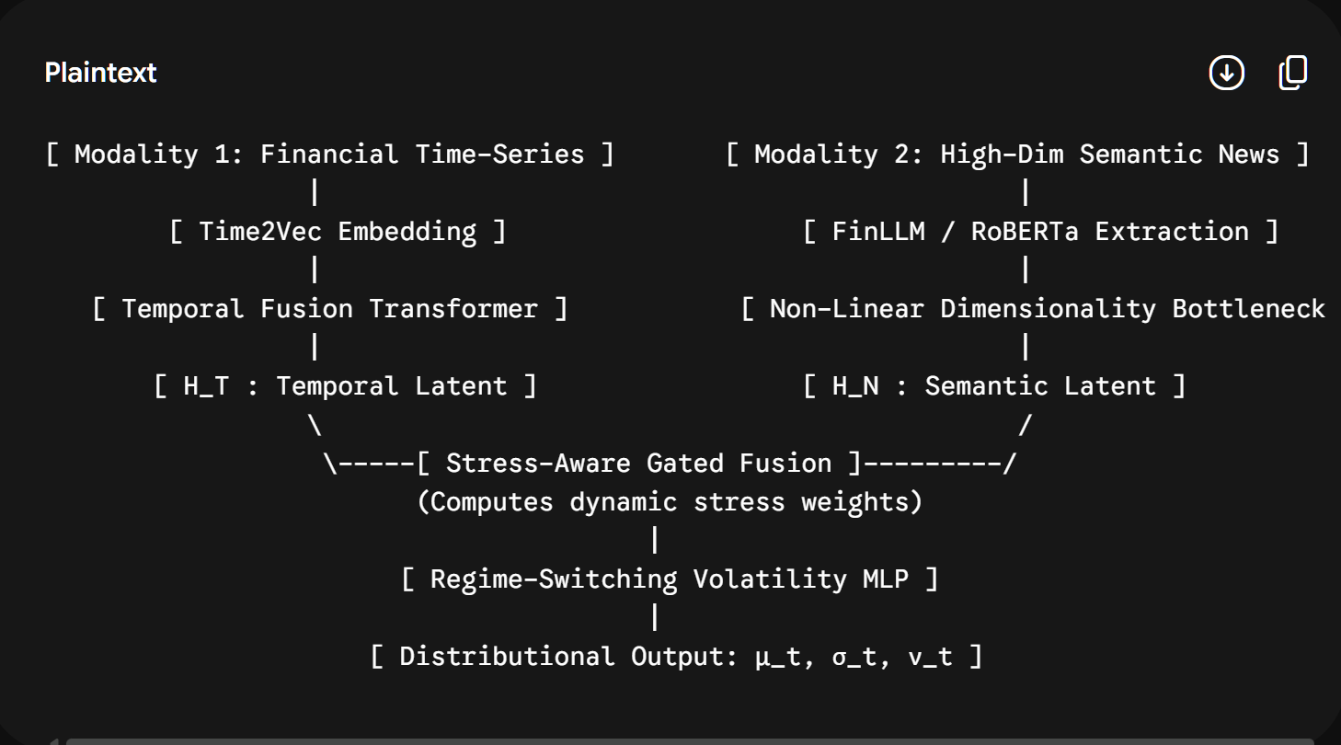
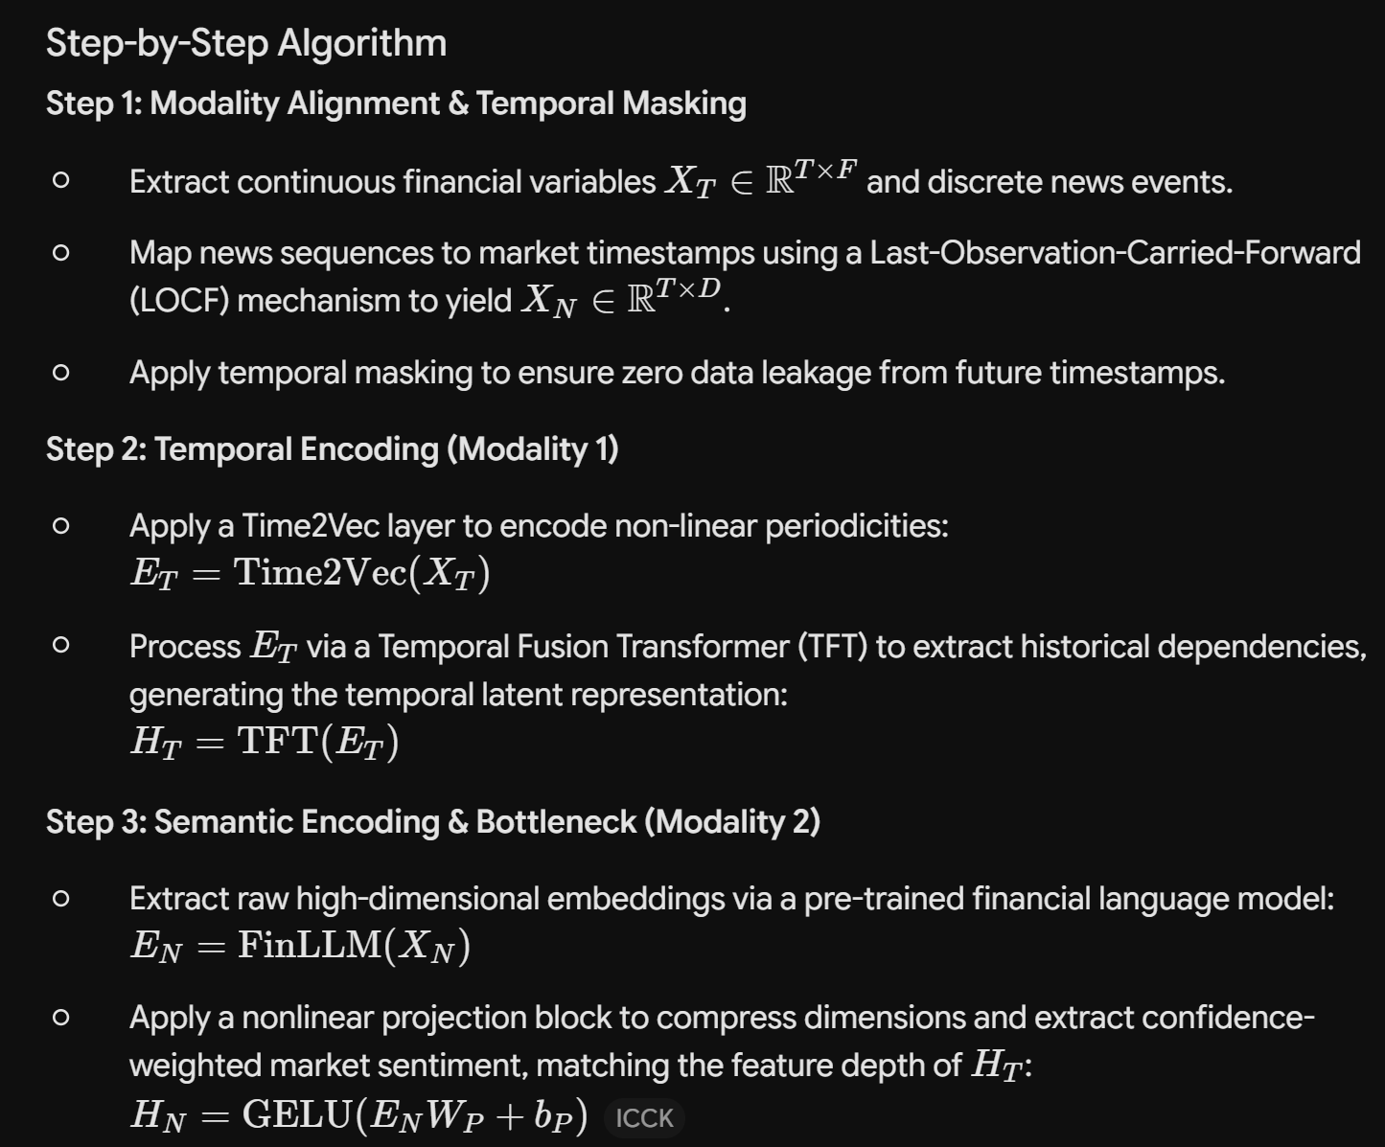
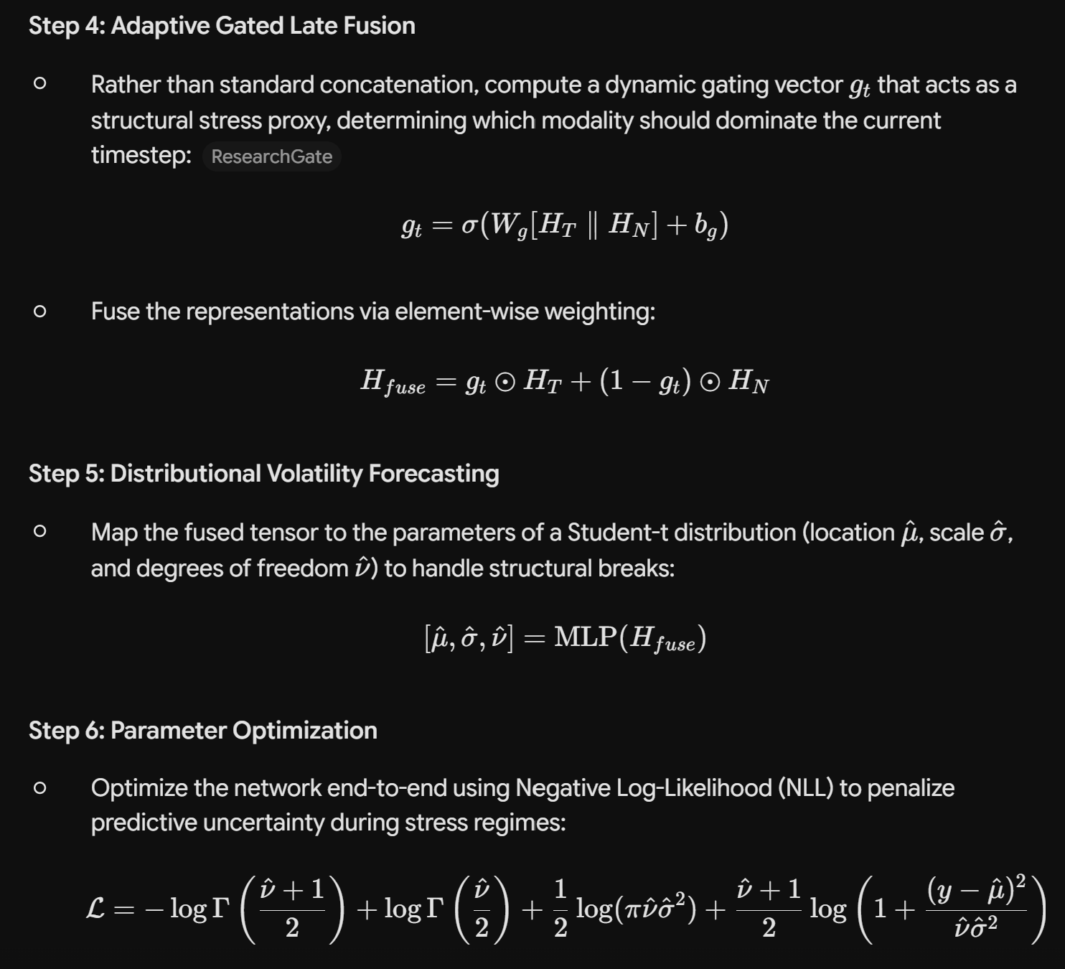
Proposed Novelty:
Neuro-Financial FusionNet introduces a dual-stream late-fusion architecture:
  - Semantic Graph Construction: Rather than using scalar sentiment or static asset graphs, the network passes daily macroeconomic news streams through FinBERT to generate 768-dimensional dense representation vectors. These embeddings serve as active node features within a Graph Attention Network (GAT) parameterized by a cross-asset correlation adjacency matrix.
  - Temporal-Relational Ensemble: The spatial relational representations extracted by the GAT are fused with the temporal sequence representations generated by a Temporal Fusion Transformer via a gated Multi-Layer Perceptron (MLP) regression head, predicting 30-day forward volatility with significantly lower error rates during structural shock windows.

4. Dataset Collection & Description
- Dataset 1: Quantitative Time-Series Data (S&P 500 / Global Equities)
  - Source / Access Link: https://www.kaggle.com/datasets/andrewmvd/sp-500-stocks
  - Format: Structured CSV (SP500_historical_data.csv)
  - Parameters & Features:
    - Date (Index / Datetime): Trading session timestamp.
    - Open (Float): Asset price at market open.
    - High (Float): Highest intra-day transaction price.
    - Low (Float): Lowest intra-day transaction price.
    - Close (Float): Unadjusted market close price.
    - Adj Close (Float): Split- and dividend-adjusted closing price.
    - Volume (Integer): Total shares traded during the session.
- Dataset 2: Micro Financial Sentiment Corpus (Financial PhraseBank)
  - Source / Access Link: https://www.kaggle.com/datasets/ankurzing/sentiment-analysis-for-financial-news
  - Format: Tabular CSV with Latin-1 Encoding (all-data.csv)
  - Parameters & Features:
    - Sentiment (Categorical String): Target polarity label (neutral, positive, negative).
    - News_Headline (Raw Text String): 4,846 expert-annotated sentences covering corporate operations, sales, acquisitions, and restructuring.
- Dataset 3: Macro Geopolitical News Stream (Daily News for Stock Market Prediction)
  - Source / Access Link: https://www.kaggle.com/datasets/aaron7sun/stocknews
  - Format: Structured CSV (Combined_News_DJIA.csv)
  - Parameters & Features:
    - Date (Datetime): Historical calendar date (2008-08-08 to 2016-07-01).
    - Label (Binary Integer): Directional movement indicator (0 for drop/steady, 1 for increase).
    - Top1 through Top25 (25 Text Columns): 25 ranked daily global news headlines tracking geopolitical conflicts, trade policies, central bank interest rate decisions, and macroeconomic events.

5. Methodology (Algorithms & Architecture Pipeline)
[Dataset 3: Top 25 News] -----> [FinBERT Embedder] ------------> [Graph Attention Network (GAT)] ---\
\
[Dataset 1: Stock Prices] ----> [Sequence Windowing] ---------> [Temporal Transformer] ------------> [Concatenation Layer] --> [MLP Regression Head] --> [30-Day Volatility]
- Step 1: Text Ingestion & Dense Embedding Generation (FinBERT)
  - Concatenate daily headlines (Top1 through Top25) from Dataset 3 for each date $t$.
  - Pass the aggregated daily text through the pre-trained ProsusAI/finbert model using Hugging Face Transformers.
  - Extract the 768-dimensional [CLS] pooled output token representation:
$$\mathbf{e}_t \in \mathbb{R}^{768}$$
  - Serialize and export all daily embedding tensors to disk (.pt files) to eliminate active GPU VRAM consumption during downstream model training.
- Step 2: Relational Graph Construction (PyTorch Geometric)
  - Define $N$ core market and sector nodes (e.g., Equities, Energy, Treasuries, Tech).
  - Compute an empirical Adjacency Matrix $\mathbf{A} \in \mathbb{R}^{N \times N}$ based on historical return correlations:
$$A_{ij} = \frac{\text{Cov}(R_i, R_j)}{\sigma_i \sigma_j}$$
  - Assign the pre-computed FinBERT embedding vectors $\mathbf{e}_t$ and current rolling volatility metrics to each node as the input feature matrix $\mathbf{X}_t \in \mathbb{R}^{N \times F}$.
  - Apply a Multi-Head Graph Attention Network (GAT) layer to compute dynamic relational dependencies:
$$\alpha_{ij} = \frac{\exp\left(\text{LeakyReLU}\left(\mathbf{a}^T [\mathbf{W}\mathbf{h}_i \,\Vert{}\, \mathbf{W}\mathbf{h}_j]\right)\right)}{\sum_{k \in \mathcal{N}_i} \exp\left(\text{LeakyReLU}\left(\mathbf{a}^T [\mathbf{W}\mathbf{h}_i \,\Vert{}\, \mathbf{W}\mathbf{h}_k]\right)\right)}$$
  - Output spatial latent vector: $\mathbf{z}_{\text{graph}} \in \mathbb{R}^{d_g}$.
- Step 3: Temporal Sequence Modeling (PyTorch Transformer)
  - Normalize historical price series from Dataset 1 using MinMaxScaler.
  - Construct sliding sequence windows of length $L = 30$ days:
$$\mathbf{S}_t = \{x_{t-L+1}, x_{t-L+2}, \dots, x_t\}$$
  - Pass sequence tensors through a Multi-Head Temporal Transformer encoder to extract time-series momentum and long-range dependencies:
$$\mathbf{z}_{\text{temp}} = \text{TransformerEncoder}(\mathbf{S}_t) \in \mathbb{R}^{d_t}$$
- Step 4: Late Fusion & Prediction Head
  - Concatenate spatial and temporal latent vectors:
$$\mathbf{z}_{\text{fused}} = [\mathbf{z}_{\text{graph}} \,\Vert{}\, \mathbf{z}_{\text{temp}}] \in \mathbb{R}^{d_g + d_t}$$
  - Pass $\mathbf{z}_{\text{fused}}$ through a Multi-Layer Perceptron (MLP) regression network with Batch Normalization, ReLU activations, and a Dropout rate of $0.3$:
$$\hat{y}_{t+30} = \mathbf{W}_2 \cdot \text{ReLU}(\mathbf{W}_1 \mathbf{z}_{\text{fused}} + \mathbf{b}_1) + b_2$$
  - $\hat{y}_{t+30}$ represents the predicted 30-day forward rolling standard deviation (volatility).

6. Code Execution Pipeline & Expected Output
- Modular Architecture:
  - src/data_preprocessing.py: Cleans CSVs, applies MinMaxScaler, generates sliding sequence arrays.
  - src/embedder.py: Batches text headlines through FinBERT, exports .pt tensor embeddings.
  - src/graph_builder.py: Constructs PyTorch Geometric Data objects containing node features and adjacency matrices.
  - src/models.py: Defines the GATModule, TemporalTransformerModule, and the unified FusionNet class.
  - src/train.py: Manages training loop, AdamW optimizer, Cosine Annealing learning rate schedule, and early stopping.
- Execution Order:
  - Execute embedder.py once on a GPU-enabled environment to pre-compute text vectors.
  - Execute data_preprocessing.py to create aligned temporal/graph datasets.
  - Execute train.py with 5-fold rolling-window cross-validation.
- Expected Output:
  - Serialized model weights checkpoint (fusionnet_best.pt).
  - Training/Validation loss curve plots (loss_curves.png).
  - Time-series regression plot mapping Actual vs. Predicted 30-Day Volatility across the test partition (volatility_forecast.png).
  - Quantitative error summary table outputted directly to standard console and saved to CSV.

7. Result Analysis & Evaluation Strategy
- Evaluation Metrics:
  - Mean Squared Error (MSE): Quantifies variance penalties for large outlier forecasting errors:
$$\text{MSE} = \frac{1}{M} \sum_{k=1}^M (y_k - \hat{y}_k)^2$$
  - Root Mean Squared Error (RMSE): Interprets prediction errors in the original volatility unit scale.
  - Mean Absolute Error (MAE): Measures average absolute magnitude of forecasting error.
  - Mean Directional Accuracy (MDA): Measures the percentage of times the model correctly predicts the direction of volatility shifts (expansion vs. contraction):
$$\text{MDA} = \frac{1}{M} \sum_{k=1}^M \mathbf{1}_{\text{sign}(y_k - y_{k-1}) == \text{sign}(\hat{y}_k - y_{k-1})}$$
- Ablation Study Matrix:
To mathematically prove the research contribution and justify journal-grade publication, the full FusionNet will be benchmarked against isolated single-stream baselines across identical train/test splits:
Architecture Model | Input Modality | Spatial Relational Awareness | Temporal Sequence Modeling | Target MSE | Target MDA
Baseline 1 (LSTM) | Price Data Only | No | Yes (Recurrent) | Benchmark | Benchmark
Baseline 2 (Pure Transformer) | Price Data Only | No | Yes (Attention) | < Baseline 1 | > Baseline 1
Baseline 3 (Pure GAT) | News Embeddings Only | Yes (Graph Attention) | No | < Baseline 1 | > Baseline 1
Neuro-Financial FusionNet | Multimodal (Price + News) | Yes (GAT) | Yes (Transf

